Project Report: Department Operation

Executive Summary
The Department Operation project was designed to provide an operational overview of each department using integrated datasets and advanced analytics in Microsoft Fabric. The objective is to enable comprehensive departmental analysis by merging multiple data sources and visualizing key performance metrics via Power BI.

Project Details
Field | Value
Project Name | Department Operation
Project Duration | Started 16-Nov-2025
Project Objectives | Operational overview for each department (organization analytics and insights into workforce, budget, and projects)
Project Lead/Team | Individual (Aspirant Data Analyst)
Platform | Microsoft Fabric, Power BI Desktop

Data Integration and Preparation
- Source Data: Six CSV files were merged, excluding the Head_Shots image dataset (please specify the names and contents of each CSV for final documentation).
- Join and Ingestion: Data from employees, departments, projects, and assignments were combined using SQL queries and views in Fabric, ensuring a unified structure for reporting.
- Image Data: Employee headshots are included for profile visualization in dashboards.

SQL Views Created
- department view: Combines employee, department, project, and assignment data, along with project statuses (Upcoming/Completed). SQL includes a CTE for project_status.
- cost view: Aggregates budgets, salary costs, and project costs per department, providing operational financial insights.
- Tables in Semantic Model: department (view), cost (view), Head_Shots (for images).
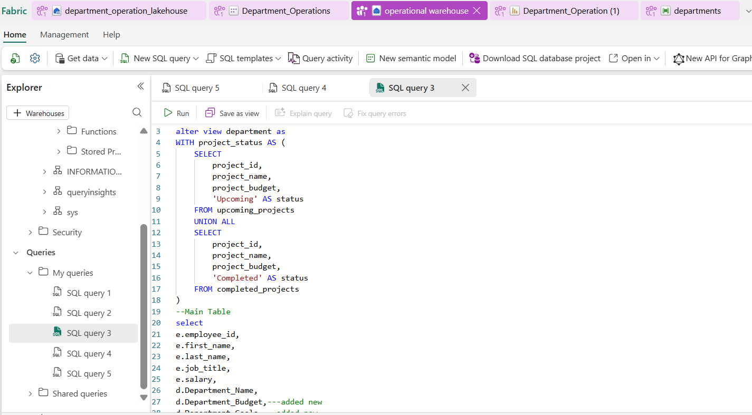

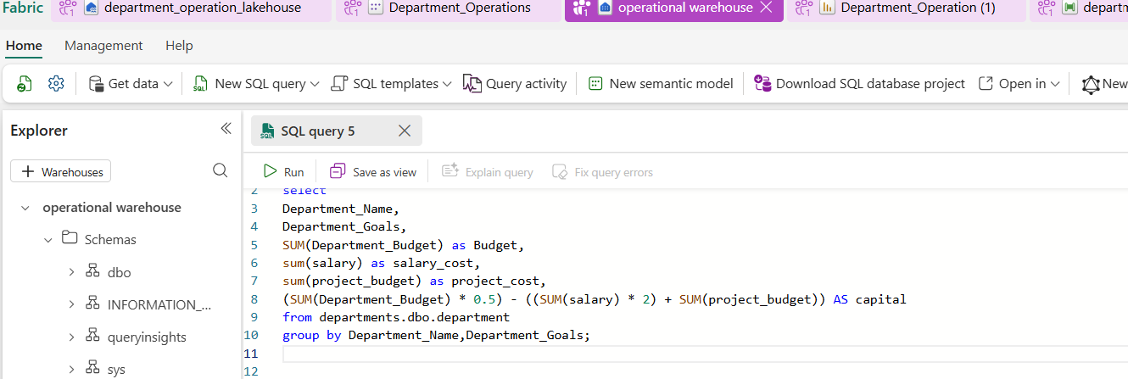

Semantic Model & Power BI Integration
- The semantic model comprises three tables (department, cost, Head_Shots) for downstream analysis.
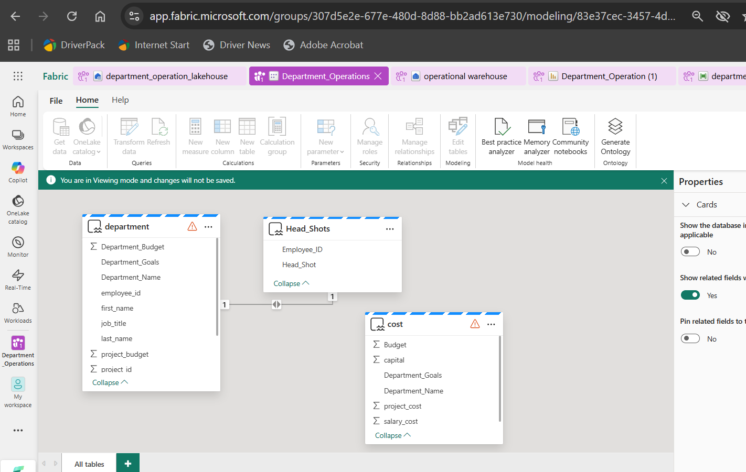

- The semantic model is ingested into Power BI for building visualizations.
- Relationships are established in the semantic model to connect employees, departments, projects, and headshots.

Power BI Dashboard Overview
- Dashboard Name: Project Overview Department Operation
- Key Visuals:
  - Donut charts for project distribution across departments
  - KPI cards for total capital and project budgets
  - Employee profile card (headshot, personal and role details, compensation)
  - Filter panels (Employee_ID, Department_Name, Status)
  - Table of department goals, costs, budgets, and capital
  - Bar charts for project budget by department and by project
- Main Metrics: Budget, Salary Cost, Project Cost, Capital, Employee details

Data Pipeline & Automation
- One data pipeline ensures scheduled refresh using Data Flow Gen2 and the semantic model.
- Automated loading and transformation maintain up-to-date reporting across Power BI.
- (Please specify refresh frequency and pipeline details for complete documentation.)
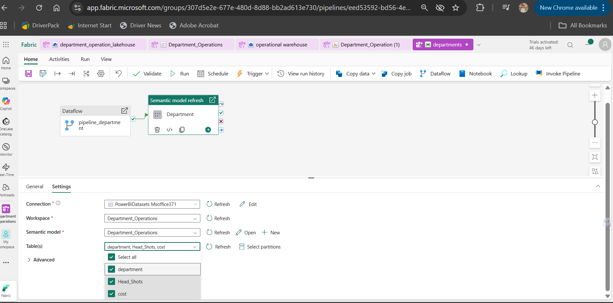
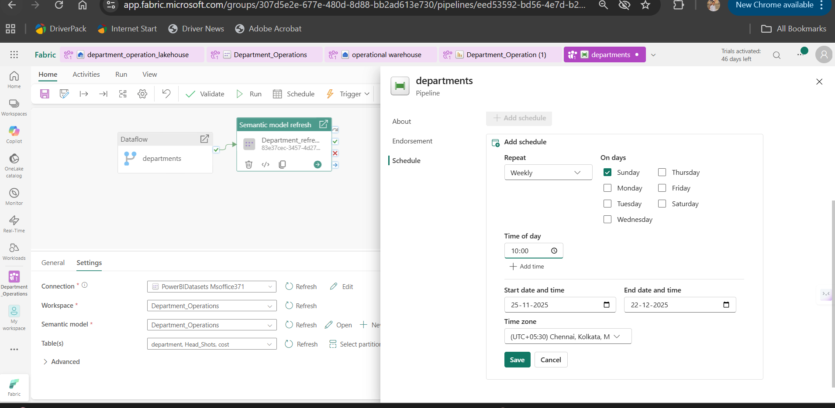

Key Insights and Impact
- Comprehensive analysis of departmental financial health, employee compensation, and project execution.
- Supports decision-making for resource allocation and operational improvements.

